**PAPER’S TITLE**

Author1,Author2

Company1,Company2

**Abstract**

This study …..

Keywords: …..

# Introduction

Write the introduction here..

# Basic Theory

Write the basic theory…

equation is shown by Eq.1 below.

|  |  |
| --- | --- |
| $$∇∙\left[\frac{k}{μB}\left(∇p-γ∇z\right)\right]=\frac{∂}{∂t}\left(\frac{ϕ}{B}\right)$$ | …(1) |

# Methodology

The methodology..

## Sub Methodology

Write the sub methodology here..

# Case Study

Write the results and discuss the results..

# Result and Discussion

Write results and discussion here..

# Conclusion

Write conclusions here..

# Recommendation

Write the recommendation here..

# Acknowledgement

Write the acknowledgement here..

# References

Write the reference here..

# List of Figures

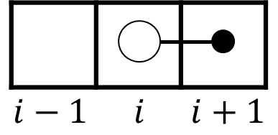

Figure 1. figure tittle

# List of Tables

Table 1. table tittle..

|  |  |  |
| --- | --- | --- |
| Column tittle | Column tittle | Column tittle |
| Content | Content | Content |
| content | content | content |

# Appendix A. tittle

Write here

# Appendix B. tittle

Write here